Tehreem ijaz

Lab 13

Task 1

C++ program that creates a file named "filename.txt" and writes the text following content into it.

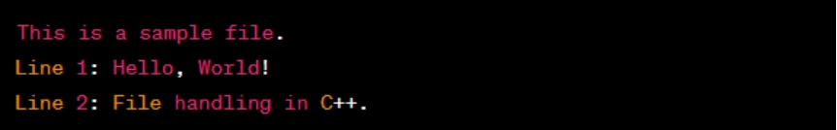

#include<iostream>

#include<fstream>

using namespace std;

int main(){

string line1 = "This is a sample file";

string line2 ="Line 1: Hello, world! \nLine 2: File handling in c++.";

//write and create file

ofstream outfile("filename.txt", ios::app);

if (!outfile){

cout<<"error; can not open file"<<endl;

return 1;

}

cout<<line1<<endl;

cout<<line2<<endl;

outfile.close();

return 0;

}

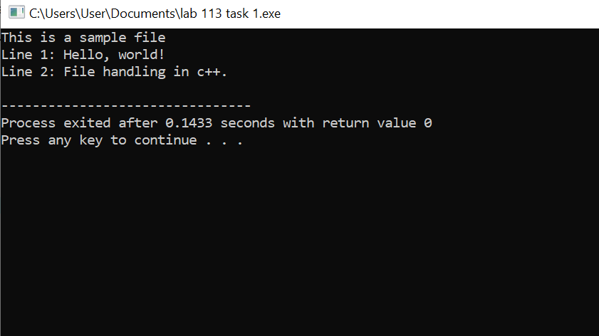

Task 2

**Writing the File:**

Write a C++ program to create a new text file named "output.txt" and write the following content into it:

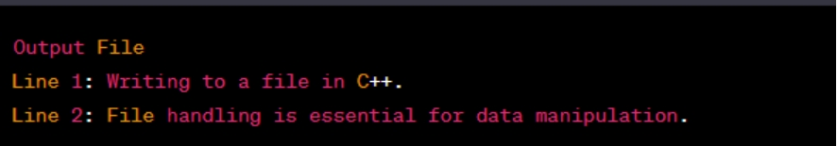

#include <iostream>

#include <fstream>

using namespace std;

int main() {

string line1 = "Output File";

string line2 = "Line 1: Writing to a file in C++.\nLine 2: File handling is essential for data manipulation.";

// Writing to "output.txt"

ofstream outfile("output.txt", ios::app);

if (!outfile) {

cout << "Error: Cannot open 'output.txt'." << endl;

return 1;

}

cout<< line1 << endl;

cout<< line2 << endl;

outfile.close();

return 0;

}

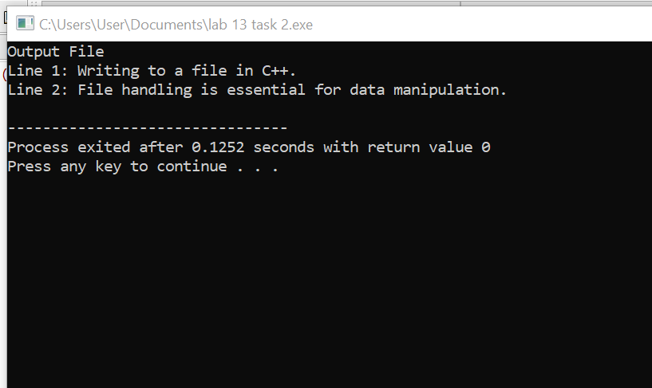

Task 3

**Reading & Writing the File:**

In a software system, there is a need to keep track of user activities for auditing and debugging purposes. The following C++ program is designed to log user activities into a file named "UserLog.txt." It records user interactions and then reads and displays the logged activities. The log file captures user login events, dashboard access, and other user interactions. If any errors occur during file operations, appropriate error messages are displayed.

**Below is the expected output:**

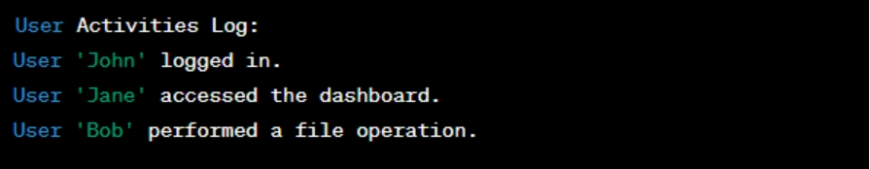

#include <iostream>

#include <fstream>

using namespace std;

int main() {

string userActivity;

// Writing user activities to "UserLog.txt"

ofstream outfile("UserLog.txt", ios::app);

if (!outfile) {

cout << "Error: Cannot open 'UserLog.txt'." << endl;

return 1;

}

outfile << "User 'John' logged in." << endl;

outfile << "User 'Jane' accessed the dashboard." << endl;

outfile << "User 'Bob' performed a file operation." << endl;

outfile.close();

cout << "'UserLog.txt' written successfully." << endl;

// Reading and displaying the content of "UserLog.txt"

ifstream infile("UserLog.txt");

if (!infile) {

cout << "Error: Cannot read 'UserLog.txt'." << endl;

return 1;

}

cout << "\n-- User Activities Log --" << endl;

while (getline(infile, userActivity)) {

cout << userActivity << endl;

}

infile.close();

return 0;

}

